The title should explain the main content with not more than 12 words

Abstract
Purpose – explain what you want to achieve with the paper. Each subsection of the abstract should not exceed 120 words. The length of the extended abstract should be approximately 500 words..
Design/methodology/approach – list the most important methodologies. Since some conference papers do not deliver full results, but propose future results, authors can provide these
Findings – what are the main conclusions (may be hypothesis).
Originality/value – elaborate the points where the research is beyond the state of the art.
Research/ Practical/ Social/ Environment implications - state the impact, the paper will provide for researchers, members of professional community, individuals, society and environment.
Research limitations - comments on the methodology and findings limitations.

Keywords:
Authors should provide up to six appropriate, short, searchable, and potentially standard keywords that encapsulate the principal topics of the paper (see: How to... ensure your article is highly downloaded).

Introduction
Paper should not exceed 5000 words in length (expected are 5-10 pages) with references and appendixes. Please allow 280 words for each figure or table.
Paper should investigate the current state of the art in the research area and provide clear proposal of going beyond that.
Authors should avoid the use of personal pronouns within the structured abstract and body of the paper (e.g. "this paper investigates..." is correct, "I investigate..." is incorrect).

Background
We are standing on the shoulders of the giants. This is the place to reference relevant previous achievements that enabled the authors to develop their research.

References
References should in short elaborate on the published results, providing the reader to follow-up the resources, needed to comprehend the authors argumentations. Please use APA 6th referencing style (APA, 2019). The use of referencing tool is preferred (MS Word menu: References/Insert citation, EndNote etc.).

Auto-citations
Authors should provide no more than one or two references to their previous publications if they relate to the proposed research results. Authors should clarify the state of the art of their previous research, and define the value-added in the proposed paper, relating to their previously published research results.

Methodology
Authors should select an appropriate research methodology. Although, we understand, that to guide us a step closer to a holistic solution of a complex problem and to investigate the implication to all parties, a systems thinking related methodologies should be applied.

Headings
Headings must be concise, with a clear indication of the distinction between the hierarchy of headings. The preferred format is for first level headings to be presented in bold format and subsequent sub-headings to be presented in italic. The names of the paragraphs in the template are only suggestions. Authors should name paragraphs according to the contents.

Figures
Figure 1: Figures in text
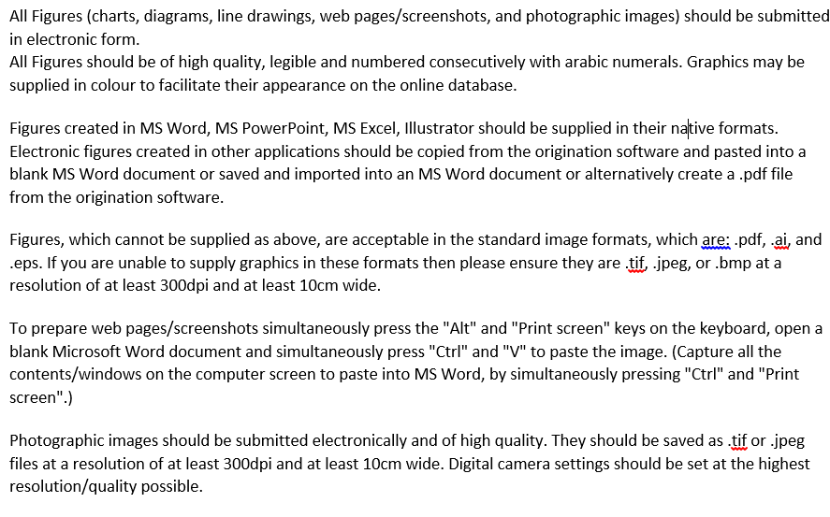
Source: (WOSC2020, 2019)
  - Abbreviations
Each abbreviation is to be explained at its first use. An example: The Viable System Model (VSM) is a model of the organisational structure of any system capable of maintaining a separate existence (Beer, 1972).
  - Notes
Notes should be used only if absolutely necessary and must be identified in the text by consecutive numbers, enclosed in square brackets and listed at the end of the paper.
  - Language
Papers are to be written in English, proofread by a native English speaker.

Summary
Among others, paper should consider the impact of the proposed solution to the system; it addresses (players, relations, processes etc.).

References
APA. (2019). Write With Clarity, Precision, and Inclusion. Retrieved 2019 from https://apastyle.apa.org/
Beer, S. (1972). Brain of the Firm. London: Penguin press.
WOSC2020. (2019). Guide for authors. Retrieved 2019 from https://www.wosc2020.org/GuideForAuthors

